

|  |
| --- |
| Financial Analysis |
|  |
| **September 30**  Gadoon Textile Mills Limited  Authored by: **Murtaza Ahmed Butt 1747185** |

### About the Company, its operations & products

Gadoon textile mills restrained (GTML) are mostly engaged within the textile enterprise of Pakistan, the fiber spinning and knitting region markedly. The company operates inside the B2B section of the industry and its production facilities include of spinning and processing all categories of cotton and handmade fiber including knitting home fabric and Jersey. The purchaser’s portfolio consists of a portion of the finest names within the textile business of Pakistan and abroad. The Yunus Brothers institution (YBG) taken into consideration this as its corporate social obligation to sign up for palms with the government in this noble reason and setup GTML. No matter the reality that the authorities unilaterally withdrew the inducement in 1991 that it offered for placing up commercial gadgets, the management of GTML determined to maintain its operations and similarly try to acquire its goals. Its miles the undying effort of GTML that made it “One of the biggest spinning unit of Pakistan”.

GTML see itself in the near future as the fabric producer of the first preference for clients at domestic and overseas, doggedly pursuing sustained management inside the markets where it competes and making its treasured contribution to the Pakistan’s exports.

The purpose of GTML is to manage a fabric enterprise entity aimed at producing best yarns thru modern era and powerful aid control, preserving high ethical and professional standards and arising to the expectancies of all our customers. We persevere to obtain the very best feasible working efficiencies and lowest costs and enlarge the enterprise through selective expansion in order that we're capable of deliver maximum fee to stakeholders.

Gadoon is a pioneer of value and advancement in the textile manufacturing sector of Pakistan. Thus following its development and expansion policy, merger with Fazal Textile Mills Limited further fortify GTML's market share. With an introduced limit of 342,420 spindles and an effective hierarchical structure has empowered it to work free creation units supported by a hostage power plant limit of 56 megawatts.

The Audit partners at GTML is Deloitte which is known to be one of the best audit firm in the world, where as the company’s head office is located in 7-A, Muhammad Ali Society, Abdul Aziz Haji Hashim Tabba Street, Karachi, The company has two factories located in different regions in Pakistan where there operations took place, Gadoon Amazai Industrial Estate, Distt. Swabi, Khyber Pakhtunkhwa and 57 K.M on Super Highway, near Karachi.

### About the Company, its operations & products

Following are some of the products that we manufacture:

• Compact Yarn

• Murata Jet Spun Yarn

• Core Spun Yarn

• 100% Grey Cotton Ring Spun Yarn

• Man-Made / Blended Yarn

• Poly / Cotton Yarn

• Murata Vortex Spun Yarn

• Open-End Yarn

• Siro Yarn

• Lycra Yarn

• Slub Yarn

• Slub Core Spun Yarn

• Compact Core Spun Yarn

• Double Compact Spun Yarn on Ring Machine

### Organizational Chart

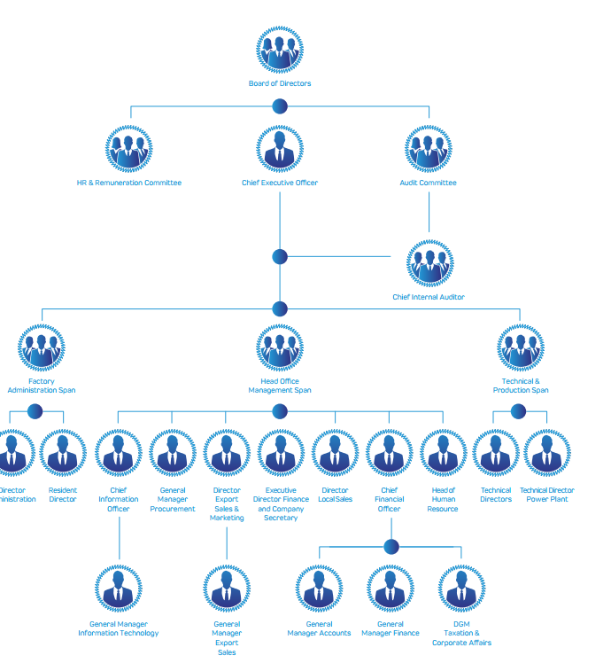

# Group Structure

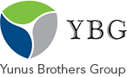 

 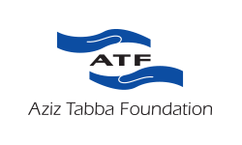 



# Group Structure

 

 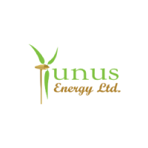

 

### Industry Analysis

The Textile Industry is the major Industrial division that plays a significant role in the financial development of the nation. It keeps on being the biggest business of Pakistan dependent on the neighborhood crude material and orders the most grounded similar points of interest in asset usage. The business has extended fundamentally since independence and now formed into one of the most grounded trade based modern sub-sector. Pakistan has risen as one of the significant cotton material item providers on the world market, with a portion of world yarn and cotton texture exchange of about 30% and 8% individually, keeping up the area as a spine of mechanical action for the nation. The yearly volume of complete world textile and garments trade is more than US$ 755 billion; Pakistan's offer is under 3%. The textile industry of Pakistan works in a genuine yet free condition as long as the acquisition and usage of raw materials are concerned. The shortage of harvests prompted the sourcing of worldwide cotton in Pakistan, which started 10 years back. Today, the country around sources 4 million bunches from the worldwide markets and creates near 12 million parcels locally. Since spinning is the start of the value chain, all worth included procedures of weaving, sewing, preparing, pieces of clothing, and made-ups are reliant upon this procedure. The impact of an inadequate yarn by the spinning portion can go directly over the whole value chain. Pakistan's turning segment caters not exclusively to the necessities of the residential business yet additionally around 33% of the complete creation of yarn is sent out different destinations.

The fast increment in spinning capacity because of technological advances has expanded the production of cotton and related items significantly. The Textile Commissioner Organization reports that there are 517 material units in the activity (40 composite units and 477 turning units) with 13.41 million spindles and 199,000 rotors introduced and 11.29 million axles and 127 thousand rotors in activity with limit usage of 83% and 84% individually. Every one of these components currently contributes about 55% of the nation's total exports. The creation of yarn expanded altogether from 2.13 billion kg in 2014-15 to 2.2 billion kg in 2017-18, in this manner indicating an expansion of 3% per annum.

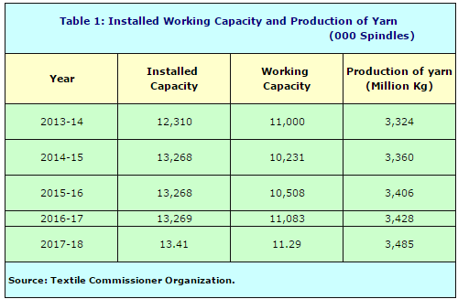

### Industry Analysis

The textile industry despite everything faces issues regardless of intensity tariff reduction of Rs 3 for each unit that is inadequate to bring back its global buyers, however, its quality yarn is bringing back worldwide purchasers being baffled by conflicting and low-quality Indian yarn. During the most recent year, the Indian government attempted to help its yarn and texture send out by giving subsidies on the export of these two things. Afterward, it declared further subsidies on a couple of centered markets that included Pakistan. Chinese moved their requests from Pakistan to the Indian spinners. Some enormous texture makers additionally favored less expensive Indian yarn over the costly domestic product.

Export of cotton yarn increased from 456 million kgs worth US$ 1.24 billion out of 2016-17 to 522 million kgs worth US$ 1.37 billion out of 2017-18, showing a development of 10%. The normal unit value acknowledgment of Pakistani cotton yarn in the worldwide markets is likewise exceptionally low contrasted with that of its rivals. The average unit cost of cotton yarn diminished from US$ 2.98/kg in 2015-16 to $ 2.63/kg in 2017-18. The average unit value acknowledgment of Pakistani cotton yarn in the international markets is low contrasted with that of its competitors. There are two significant reasons. To begin with, cotton quality; the decay in cotton quality happens during inadmissible capacity and treatment of seed cotton by producers. The vast majority of the ginners enjoy acts of neglect including a blend of assortments and grades, low principles of ginning and expansion of overabundance dampness not long before squeezing build up into bundles. This outcomes in the creation of defiled yarn that sells at a much lower cost. The second explanation behind low unit esteem acknowledgment is the item blend of Pakistani cotton yarn. Over 70% of the complete yarn creation is that obviously and medium count yarns. In yarn exports, this rate is about 99%, and in this way, coarse and medium checks bring a lower value contrasted with fine and superfine includes that at last shows in low unit esteem acknowledgment. Additionally, the portion of other high value-added yarns like colored and melange, or center spun yarns are small in terms of total export volume. Exports of cotton yarn from Pakistan are given in the following table.

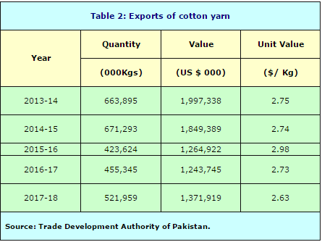

### Industry Analysis

**Challenges**

Pakistani textile industry considered as the foundation of the export sector is confronting new issues that ought to be managed immediately. The textile industry disintegrating under high energy costs struck up discounts and tight monetary policy is confronting extreme competition from India, Bangladesh, Vietnam, Thailand and different states in the foreign market. Along these lines, the administration should take serious initiatives to protect the nearby business which is the most elevated remote trade worker and the biggest urban work supplier. The All Pakistan Textile Mills Association (APTMA) needs to improve the nature of its products, update the technology utilized and support viable Research and Development (R&D) so as to contend globally. In any case, APTMA contends different factors, for example, high-loan costs and cost of data sources, non-favorable government approaches, and non-ensured energy supplies block their competitiveness. While a few makers have overhauled their production units by introducing technologically advanced machinery and gear, the pattern has neglected to get energy over the whole turning division. During the previous two years, Pakistan has a precarious dive in imports of material apparatus indeed. Textile machinery imports for FY18 checked in at US$ 325 million which is the most minimal since the base of US$ 252 million in FY09. Pakistan is among the main cotton-creating nations, anyway from the most recent couple of years its cotton creation is on the descending side and declined radically to 12 million parcels in 2017-18. As indicated by the report, Pakistan, which is the world's fourth-biggest cotton-delivering nation, misses the mark concerning around 4.0 million bundles per year to fulfill the neighborhood need of about 16 million parcels. State Bank of Pakistan (SBP) in an ongoing report saw that with satisfactory accessibility of raw materials in the nation, Pakistan could have exceeded expectations in worldwide engineered material markets, for example, Vietnam, Bangladesh, and Cambodia, are leading exporters of synthetic textiles following China. Globally cotton is presently 30% of the absolute fiber utilization and synthetic fiber and fiber are currently at 70%, while the circumstance locally is an incredible inverse.

### Financial Analysis

**Statement of Financial Performance**

For Gardoon textile limited the financial year 2019 was the most favorable so far, the sales revenue was recorded 31.217 billion in FY”19 which is the highest sales revenue compared with the past years in the year FY”19 the company has increased its sales revenue by 13.29% compared with FY”18 27.555 billion sales revenue, this is due to aggressive marketing strategy including distinguishing identification of new markets (locally and globally) and widening product range, along with appreciation in market prices, however it is to be seen that the company is constantly improving form the past year and in FY’17 the company has shown a 23.249 billion sales revenue which was recorded as the highest sales revenue from the comparison of its past years , If the FY”17 sales revenue is compared with the FY”19, it shows a growth of 34.27% significant growth which is considered to be tremendous if we just even see a glimpse the figures from the industry.

As we move on further on the profit and loss account we can notice upward shift in the gross profit margin in FY”19 which shows 9.27% against its sales revenue, it has significantly increased by 31.3% from the FY”18 (7.06) and 67.36 % from FY”17 (5.72%), however on an average the company has improved 49.33% on an average from its previous financial years, The increase in GP is mainly attributable to better market price of the product along with procuring the right mix of raw material at the most economical rates and mainly on account of contained power and fuel cost, efficient utilization of labor and availability of raw materials at competitive rates.

Financial cost of the company started to decline in the FY”17 however in FY”19 financial cost has increased by 91.09% (1.098 billion) against the FY’18 (0.574 billion), and compared with FY”17 the financial cost has increased by 220.5% in FY”19. The average change in the finance cost is to be estimated around 155.79% which is considered to be a much higher increase in the past financial years, increased trend significantly for the last two years mainly on account of increasing working requirements and increase in KIBOR rates, and Company has started to obtained long term finance facility from the year 2018, which has resulted in increase in long term finance percentage.

The Net profit ratio in the FY”19 is 3.78% which is considered to be satisfactory however if we compare the ratio with the FY”18 (4.3%), there is a downward fall observed in the FY”19 by 12.09% and a comparison with FY”17 (3.47%) shows an increase of 8.93% growth in the net profit ratio, The average growth compared with the past financial year is to be estimated around negative growth (-1.985%) for the FY”19, however, net profit ratio for the year 2018 was better than 2019, mainly on account of availability of rebate on export of yarn in 2018 along with reduced finance cost.

The noticeable increase in the Taxation amount rose by 67.28% in the FY”19 (Rs482, 355,000) compared with FY”18 (Rs288, 350,000), this is because of increased in current year mainly on account of reduction of tax credit on investments from 10% to 5%, introduced through the Finance Act, 2019.

Operating Profit to sales ratios has been identified as 7.09% for the FY”19, the comparison shows an increase of 52.14% compared the ratio of FY”18 (4.66%) and if compared with the ratio of FY”17 (3.68%) it shows significant growth of 92.66% in the ratio, moreover on an average the operating profit to sales ratio has increased by 72.4% compared to its previous financial years, this is due to reduction in cost of goods sold, less wastages and efficiency and effectiveness in finding raw materials at more economical rates without compromising the quality, hence this results in a favorable variance for Gadoon in the FY”19.

The return on equity of FY”19 is 13.62% which is a good sign in the current economic situation, however if we compare it with the FY”18 (15.22%) it seems to face a dent by 10.51%, it does not means that the company is not utilizing its resources efficiently, well in the FY”19 as there was also a major amount of tax paid in the following year and still the company managed to maintain its return on equity, however if we compare the FY”19 with the FY”17 (11.61%) the result we would get is an increase by 17.31% in the ratio of return on equity. Moreover on an average the return on equity ratio has increased by 0.55% for the flowing pervious financial years.

The Capital Employed for the FY”19 is 26.74%, which means that the company is doing good in the industry considering the current economic situation, if we compare the capital employed of the FY”19 (26.74%) with FY”18 (25.33%), the ratio has increased by 5.5% creating a positive impact for investors for the company, the trend of capital employed is keen to be upwards/increasing trend, This has helped the company in increasing its shareholder equity by 25% in FY”19 comparing it with the FY”17, concluding that investors are more than satisfied with the results and performance of the company.

Overall profitability ratios depicts improved trends for the last three years. Even though GP ratio has increased, but PAT to sales ratio has decreased on account of non-availability of rebate on export sales of yarn for this year, which contributed PRs. 355.64 million last year. As significant CAPEX has been made in the second half of current year, therefore the benefit of these investments will come in next year and accordingly return on fixed assets will improve in the upcoming years.

**Statement of Financial Position:**

Fixed asset turnover ranges between 3.62 to 3.06 times in the past 3 years, In the FY”19 the ratio had a downward fall, however this clearly does not mean that it is a bad sign for the investors, in fact the ratios falls due to addition in the Fixed assets by Rs.2,078,431,000 in the FY”19, the investors might see this as opportunity because it enhances the production capacity of the company making it more profitable in the future and in its industry.

Total asset turnover varies from 1.28 to 1.19 in the past 3 financial years, in the FY”19 the ratio had a downward fall in its nature, this clearly does not indicate a negative impact for investors, this is because the total assets have increased by 17.9% in FY”19 compared with FY”18, whereas the revenue is increased by 13.29% in the FY”19 compared with FY”18, this is just a short term effect, however this will clearly benefit the company in long term as the company has invested in PPE and technology for future growth perspectives.

Operating Cycle for Gardoon in the FY”19 is 101 days, which shows an increase in the graph, it has increased significantly if we compare it with the previous operating cycle of FY”18 which was 86 days, However, during the current year, mainly on account of increase in trade debts (owing to increase in sales in the month of June 2019) and increase in inventory levels (to secure the risk of price increase), the operating cycle has increased. This will benefit the company in long run when the price of raw material will increase and Gadoon will have favorable variances in the upcoming financial years compared with the industry, This is a great sight for investors as in future the company can also benefit from higher profit margins and extracting more profit from the market or can distinguish itself from competitors in terms of price in the future.

Weighted average cost of debt reported 9.52% from 6.02% which seems a significant increase from rise in debt in a period of one year. It can also be concluded from increase in debt to equity in terms of book and market values. Accordingly shareholders requires higher return on higher risk associated with debt of the company subsequently company’s WACC is likely to effect and rise from their weights and cost. The amount of debt has increased due to further borrowing form the financial sectors to invest in PPE and technology.

For the Investors Gadoon is a very good investment opportunity as it has a good EPS of 42.32 in FY”19. This is a very good amount of return, as the trend shows a growth in the EPS compared with the past financial years, this is an indication of opportunity towards the investors, the company has very strong grip the industry and is well known and backed by its huge group structure and financial institutions.

**Analysis of Cash flows**

In Analysis for the year Cash ﬂow from operating activities shows that the Company has generated Cash from its activities throughout the year, with the exception of the year 2018, except for the year 2018 and 2014, where cash ﬂows were negative mainly on account of increased investment in inventories with expected rise in raw material prices due to general inflation.

The Company's net cash flow from operating activities for the year is Rs. 986.06 million installments of Rs. 1.31 billion in regard to taxes, tip and personal assessments, which speaks to that the Company is working well as far as the generation of money, which could have been shockingly better if exchange obligations had not expanded by Rs. 1.05 billion, bringing about blockage of working capital. The expansion in exchange obligations is for the most part by virtue of expansion in deals in the long stretch of June 2019. Further, the income from operations shows that the Company has created money from its tasks throughout the years, with the exception of the year 2018 and 2014.

The Company's net cash utilized in contributing movement throughout the years, for the most part, speaks to sum put resources into the acquisition of machinery and related common work

The Company's net cash generated from financing activities is certain throughout the previous two years mostly by virtue of receipt of long haul account. Further, throughout the years the money utilized in financing exercises essentially speak to profit installments to the investors

**Conclusion and Recommendations:**

The aggregate performance of Gadoon is satisfactory, with increasing profit margins and clear indicators about future growth, thus an investor can easily identify the opportunities of growth and increased market share in the near future, According to the observation the textile industry is coming back to Pakistan, Brands like Pull&Bear, H&M, Zara and other famous brands are being manufactured in Pakistan, the demand for yarn has a potential to shifts right creating more opportunity for Gardoon to grab in the near future.

With such huge profits, Gadoon Textile Limited can diversify their operations into manufacturing garment by doing a forward integration with some well-known company like artistic textile to capture the further market and to take advantage of low price in the market, this will help the organization to grow further and make good profits in worst economic conditions as most of the garments which is manufactured in Pakistan is exported globally.

The latest update from the Global pandemic might slow down the demand for Gardoon and the whole industry, thus making its profits decrease and facing a dent in their sales, The company has to seek for alternative to pull off their finance cost and debts as they will be creating problem for the company in the current situation, to overcome this problem, Gardoon can take interest free loan or a loan at very minimal finance cost from its group structure so its operations and liquidity problems does not arise in near future.

**References**

Pakistan Bureau of Statistics.

Pakistan Economic Survey.

Trade Development Authority of Pakistan.

|  |  |  |  |  |
| --- | --- | --- | --- | --- |
| **Profitability** | **2019** | **2018** | **2017** | **2016** |
|  |  |  |  |  |
| Gross Profit Margin | 9.27% | 7.06% | 5.75% | 3.41% |
|  |  |  |  |  |
| Operating Profit Margin | 3.26% | 1.99% | 1.89% | -1.48% |
|  |  |  |  |  |
| Net Profit Margin | 3.80% | 4.30% | 3.47% | -1.29% |
|  |  |  |  |  |
| Return of Equity (Average) | 13.62% | 15.22% | 11.61% | -4.10% |
|  |  |  |  |  |
| Return on Assets | 13.33% | 15.56% | 10.64% | -3.41% |
|  |  |  |  |  |
| Return on Capital Employed | 11.63% | 7.17% |  |  |
|  |  |  |  |  |
| **Activity / Efficiency** |  |  |  |  |
|  |  |  |  |  |
| Fixed Asset Turnover | 3.51 | 3.62 | 3.06 | 2.65 |
|  |  |  |  |  |
| Total Asset Turnover | 1.24 | 1.27 | 1.18 | 0.80 |
|  |  |  |  |  |
| Account Receivable Turnover Days | 34 | 28 | 26 | 31 |
|  |  |  |  |  |
| Inventory Turnover Days | 101 | 93 | 89 | 90 |
|  |  |  |  |  |
| Payables Turnover Days | 54 | 48 |  |  |
|  |  |  |  |  |
| **Liquidity** |  |  |  |  |
|  |  |  |  |  |
| Current Ratio | 1.02 | 0.96 | 0.87 | 0.80 |
|  |  |  |  |  |
| Quick Ratio | 0.38 | - | - | - |
|  |  |  |  |  |
| **Gearing** |  |  |  |  |
|  |  |  |  |  |
| Debt to Equity (Book Value) | 29.05% | 7.24% | - | - |
|  |  |  |  |  |
| Interest Coverage | 2.52 | 3.56 | 4.17 | 0.79 |
|  |  |  |  |  |
| **Investor's Ratio** |  |  |  |  |
|  |  |  |  |  |
| EPS | 42.32 | 42.29 | 28.79 | -9.77 |